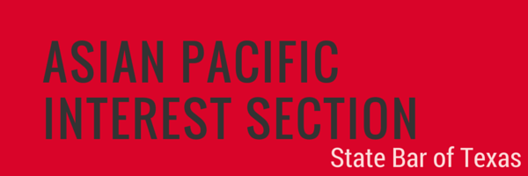

NOMINATION FORM
JUSTICE DAVID WELLINGTON CHEW AWARD

The Asian Pacific Interest Section (APIS) Justice David Wellington Chew Award is the highest honor awarded by APIS every year, recognizing the outstanding achievements, commitment, and leadership of a lawyer who has paved the way for the advancement of other Asian Pacific American (APA) attorneys. Established in 2002, the Award was named after Justice Chew, former Chief Justice of the Eighth Court of Appeals and one of the first Asian Pacific Americans in the Texas judiciary. Award recipients demonstrate vision, courage, and tenacity in their practice, and they have made substantial and lasting contributions to the APA legal profession, as well as the broader APA community. Nominees must be licensed to practice law in Texas, have paid membership dues prescribed by the Supreme Court of Texas, and be members in good standing of the State Bar. It is highly preferred that the Nominee be present at the APIS Conference Awards Ceremony to receive the award.

Nominator Information
Name: Relationship to Nominee:
Firm, Company, or Organization: Title:
Address:
Phone: Email:

Nominee Information
Name: TX Bar Number:
Firm, Company, or Organization: Title:
Address:
Phone: Email:
Please use additional pages to answer the following questions. The nomination package shall be strictly limited to no more than 8 total pages, including this form and all supporting documentation.

- Background Information: provide background information, including the nominee’s career.

- Lifetime Achievements: provide details of lifetime achievements that have paved the way for the advancement of APA attorneys and/or advancement and strengthening of the APA community.

- Inspirational Leadership & Breaking Barriers: provide details of inspirational leadership in his/her chosen field(s) of endeavor; provide details of accomplishments that broke a barrier or achieved a goal not yet previously attained by an Asian Pacific American.

- APIS/Affiliate Involvement: provide details of prior involvement with APIS on a state level or at the affiliate level, if applicable.

- Other Relevant Information: additional information and supporting materials, such as letters of support, curriculum vitae, or resumé, are welcome but not required.

Nomination must be received no later than 5:00 p.m., Friday, January 31, 2020. Submit the application and any supporting materials to: Shruti Krishnan at shruti@ziosk.com. All submissions will be acknowledged with a reply. The award will be presented at the Awards Ceremony on Friday, April 3, 2020 at the Hilton in Austin, Texas, in conjunction with the 2020 Annual APIS Conference. We request that award winner be available to attend the Awards Ceremony.

