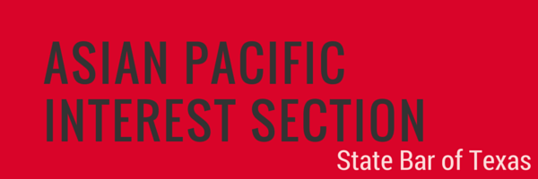

NOMINATION FORM
OUTSTANDING MENTOR AWARD

The Asian Pacific Interest Section (APIS) Outstanding Mentor Award is awarded to a lawyer in Texas who has consistently demonstrated a commitment to mentoring young lawyers in his or her legal community. Nominees must be licensed to practice law in Texas, have paid membership dues prescribed by the Supreme Court of Texas, and be members in good standing of the State Bar. The Awards Committee will consider all outstanding qualities of a nominee, including (1) service as a role model to young lawyers in the legal community; (2) fostering the development of young lawyers; and (3) significant contributions to the profession and/or the community. It is highly preferred that the Nominee be present at the APIS Conference Awards Ceremony to receive the award.

Nominator Information
Name: Relationship to Nominee:
Firm, Company, or Organization: Title:
Address:
Phone: Email:

Nominee Information
Name: TX Bar Number:
Firm, Company, or Organization: Title:
Address:
Phone: Email:

Please use additional pages to answer the following questions. The nomination package shall be strictly limited to no more than 8 total pages, including this form and all supporting documentation.

- Background Information: provide background information concerning the nominee’s career.

- Service as a Role Model: describe the nominee’s service as a role model to young lawyers, including success stories and overall impact.

- Fostering the Development of Young Lawyers: describe the nominee’s contributions to fostering the development of young lawyers, including success stories and overall impact.

- Service to the Profession and/or the Community: describe the nominee’s service to the profession and/or the community, including the length of time involved, and overall impact.

- Other Relevant Information: additional information and supporting materials, such as letters of support, curriculum vitae, or resumé, are welcome but not required.

Nomination must be received no later than 5:00 p.m., Friday, January 31, 2020. Submit the application and any supporting materials to: Shruti Krishnan at shruti@ziosk.com. All submissions will be acknowledged with a reply. The award will be presented at the Awards Ceremony on Friday, April 3, 2020 at the Hilton in Austin, Texas, in conjunction with the 2020 Annual APIS Conference. We request that award winner be available to attend the Awards Ceremony.

