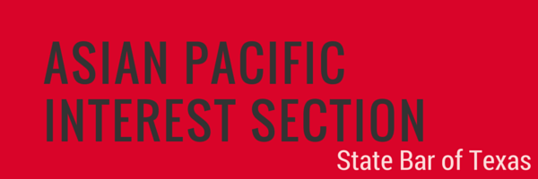

NOMINATION FORM
PRO BONO AWARD

The Asian Pacific Interest Section (APIS) Pro Bono Award seeks to recognize an attorney or a team of attorneys for outstanding achievements in pro bono service that (1) involved impactful litigation or other legal assistance to advance or protect civil rights or (2) provided direct legal services to individuals in furtherance of the administration of legal and social justice. The subject matter and difficulty of the case(s) or matter(s) and time expended are factors considered in selecting the award recipient. Examples of pro bono service may include, but are not limited to, commitment to a complex criminal habeas appeal or difficult civil rights case, routine representation of immigrant clients in cases that might affect their quality of life, or successful advocacy for legislation that improves the delivery of pro bono legal services. Nominees must be licensed to practice law in Texas, have paid membership dues prescribed by the Supreme Court of Texas, and be members in good standing of the State Bar. It is highly preferred that the Nominee be present at the APIS Conference Awards Ceremony to receive the award.

Nominator Information
Name: Relationship to Nominee:
Firm, Company, or Organization:
Title:
Address:
Phone: Email:
Relationship to Nominee:

Nominee Information
Name: TX Bar Number:
Firm, Company, or Organization:
Title:
Address:
Phone: Email:

Please use additional pages to answer the following questions. The nomination package shall be strictly limited to no more than 8 total pages, including this form and all supporting documentation.

- Work Performed: provide a statement detailing work performed with case summaries (maximum of 2 pages).

- Other Relevant Information: provide copies of reported decisions, news clippings, or published opinions, if any. (This is helpful, but not mandatory.)

Nomination must be received no later than 5:00 p.m., Friday, January 31, 2020. Submit the application and any supporting materials to: Shruti Krishnan at shruti@ziosk.com. All submissions will be acknowledged with a reply. The award will be presented at the Awards Ceremony on Friday, April 3, 2020 at the Hilton in Austin, Texas, in conjunction with the 2020 Annual APIS Conference. We request that award winner be available to attend the Awards Ceremony.

